**CLOUD COMPUTING LAB**

**Name: Maria Abdul Malik**

**Reg No: 2023-BSE-076**

**Submitted to: Sir Muhammad Shoaib**

**Class: 5B**

**LAB #12**

**Task 0 Lab Setup (Codespace & GH CLI)**

* task0_codespace_create_and_list. png



* task0_codespace_ssh_connected.png

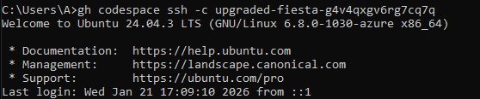

## Task 1 — Organize Terraform code into separate files

* task1_project_directory.png



* task1_files_created.png

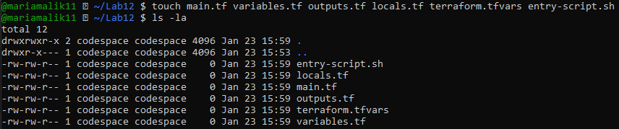

* task1_variables_tf.png

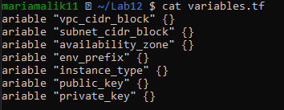

* task1_outputs_tf.png

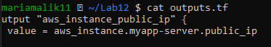

* task1_locals_tf.png

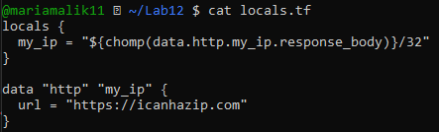

* task1_terraform_tfvars.png

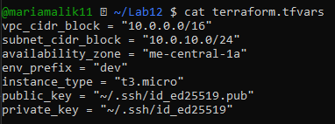

* task1_main_tf.png

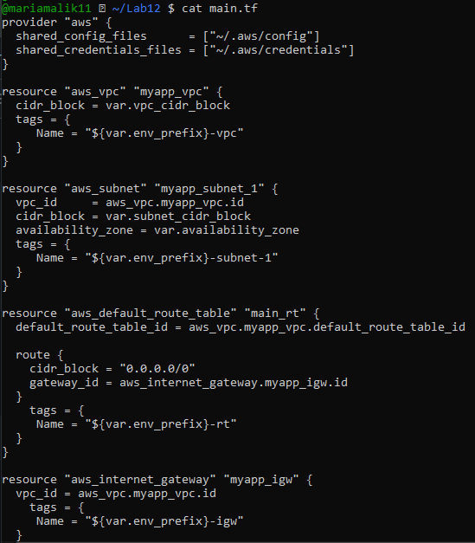

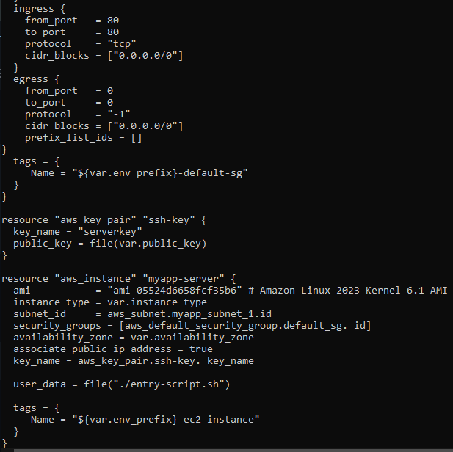

* task1_entry_script.png

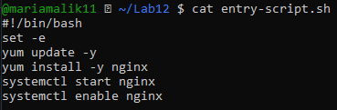

* task1_ssh_keygen.png

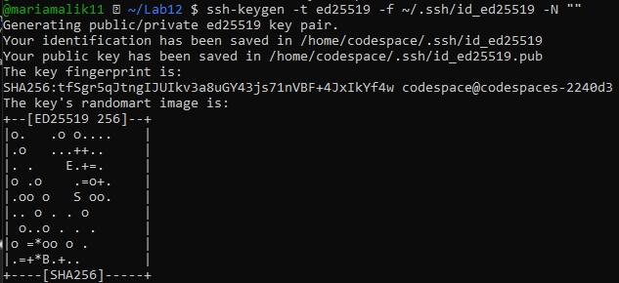

* task1_terraform_init.png

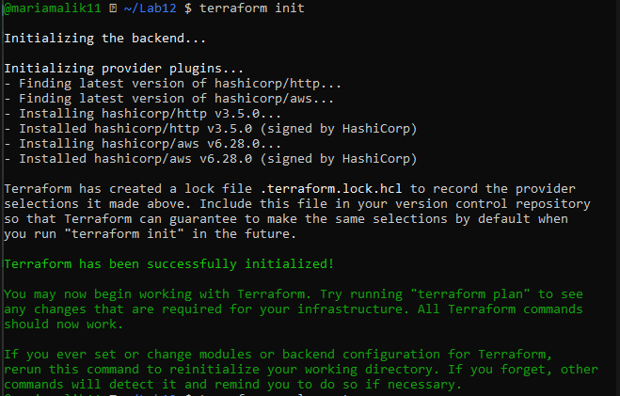

* task1_terraform_apply.png

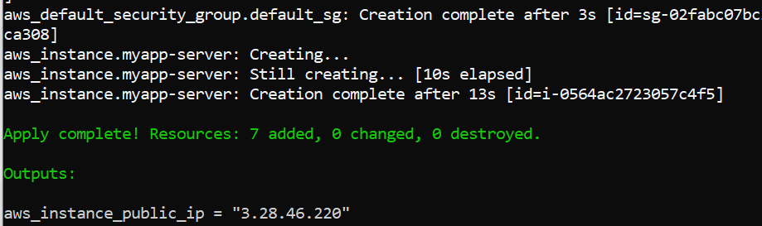

* task1_terraform_output.png

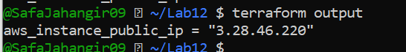

* task1_nginx_browser.png

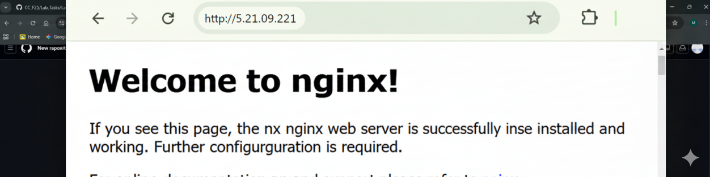

* task1_terraform_destroy.png

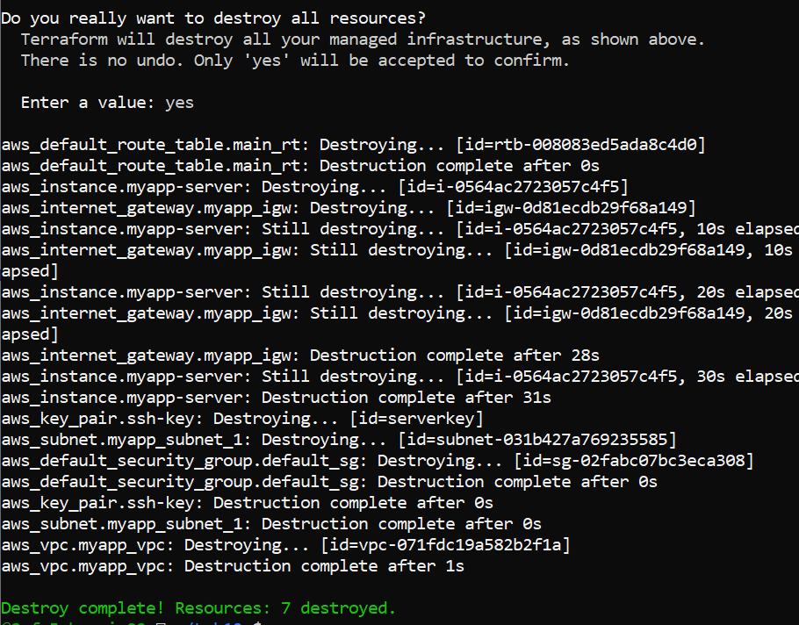

## Task 2 — Use remote-exec provisioner

* task2_main_tf_remote_exec.png

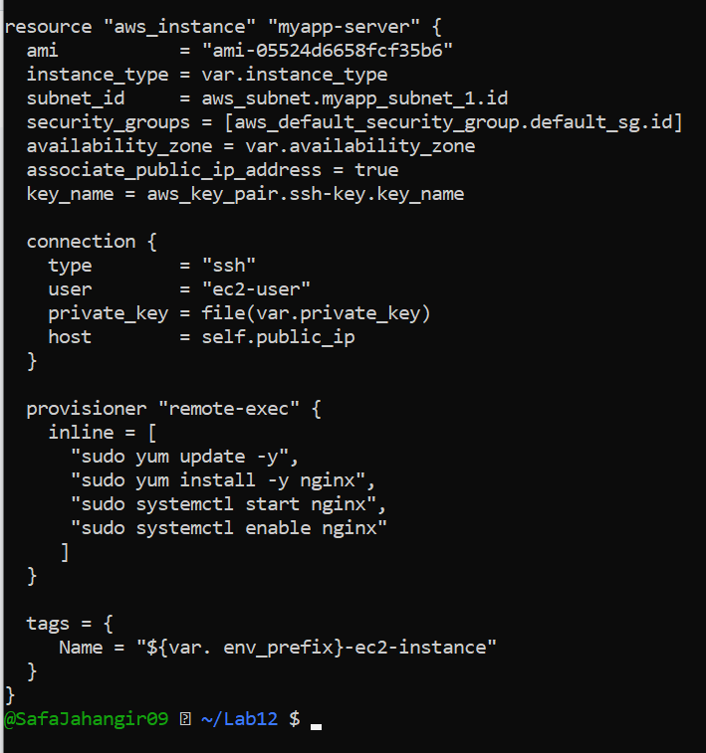

* task2_terraform_apply.png

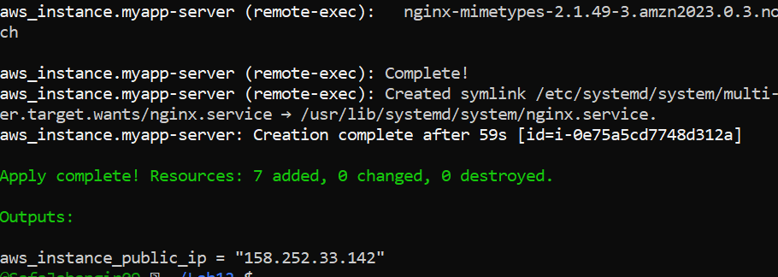

* task2_terraform_output.png



* task2_nginx_browser.png

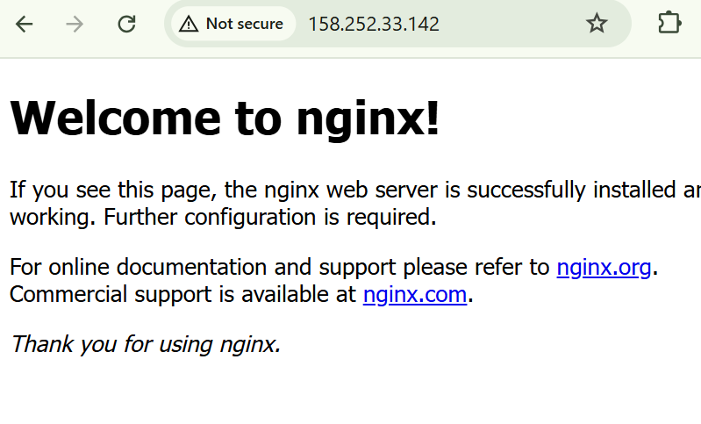

## Task 3 — Use file and local-exec provisioners

* task3_main_tf_all_provisioners.png

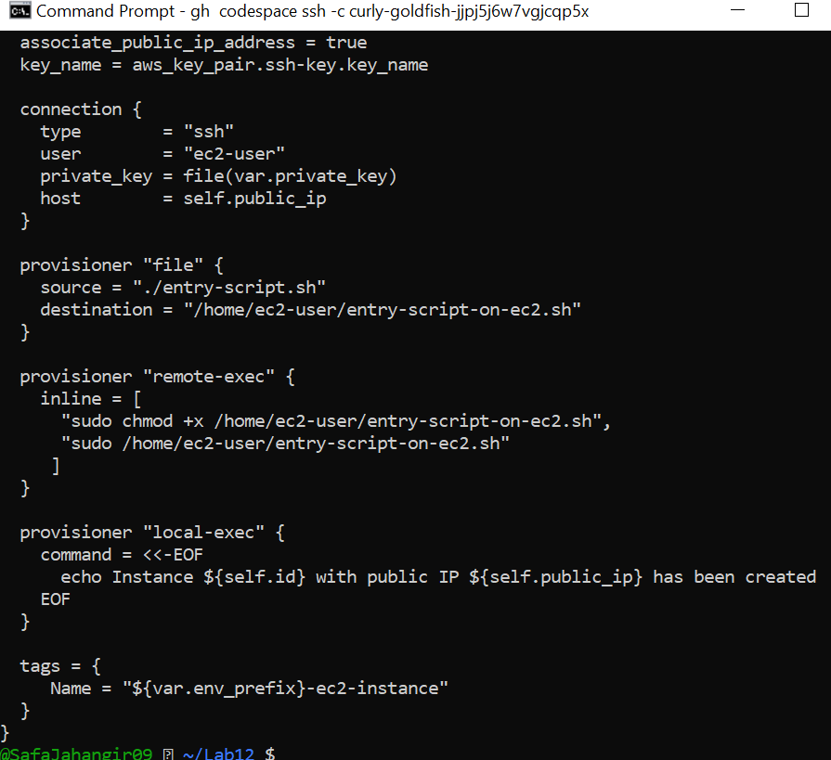

* task3_terraform_apply.png

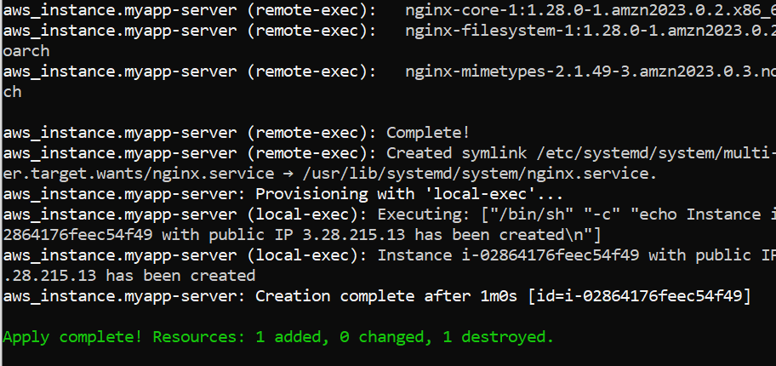

* task3_terraform_output.png



* task3_nginx_browser.png

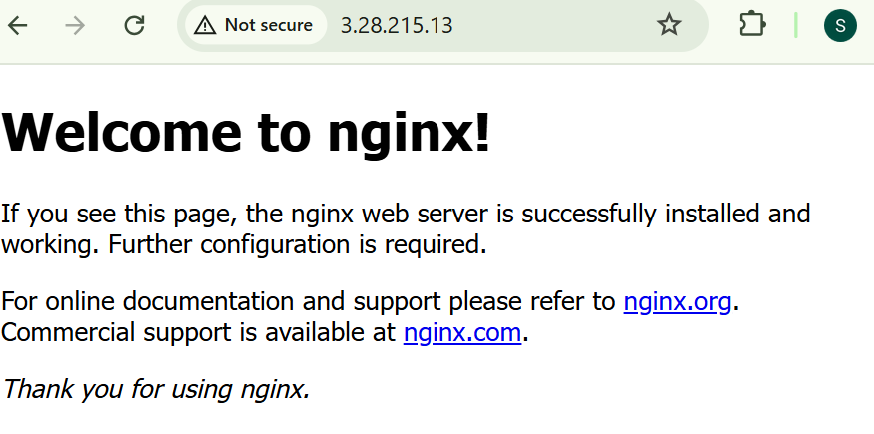

* task3_terraform_destroy.png

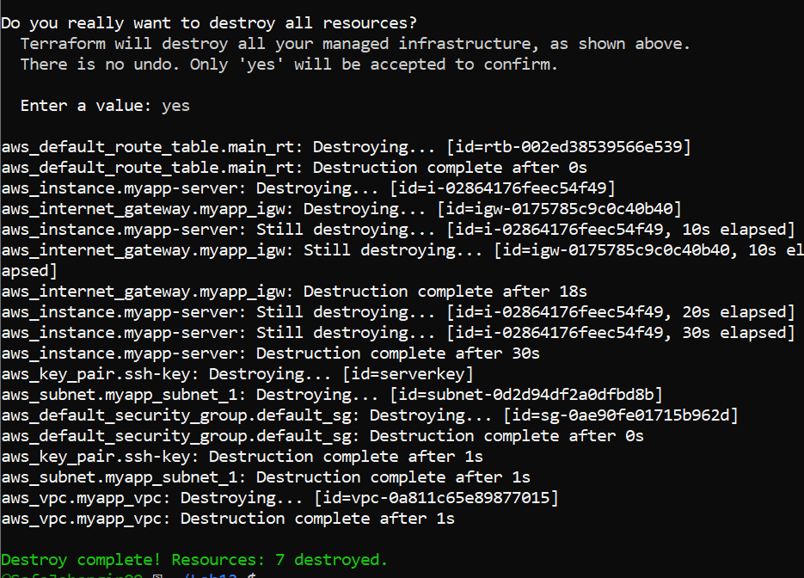

* task3_main_tf_restored.png

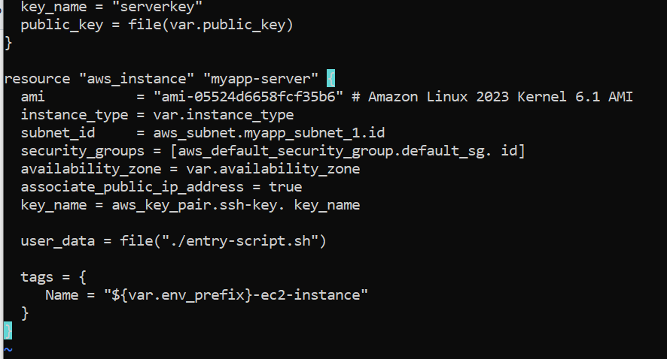

## Task 4 — Create Terraform modules (subnet module)

* task4_module_structure.png

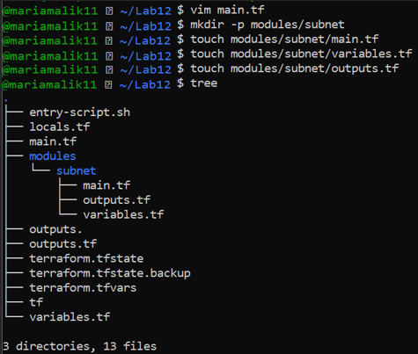

* task4_subnet_variables.png

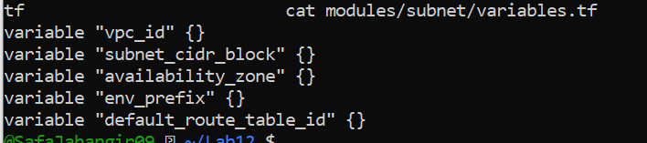

* task4_subnet_main.png

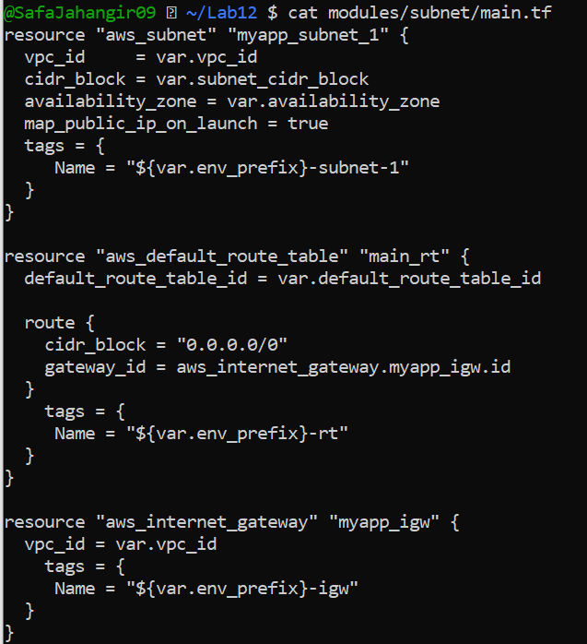

* task4_subnet_outputs.png

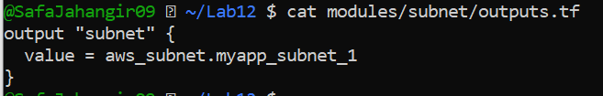

* task4_main_tf_with_module.png

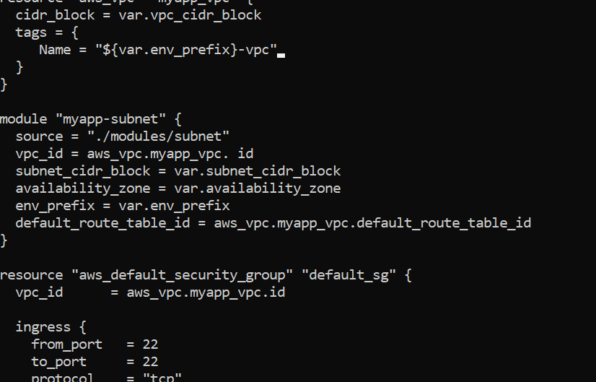

* task4_terraform_init.png

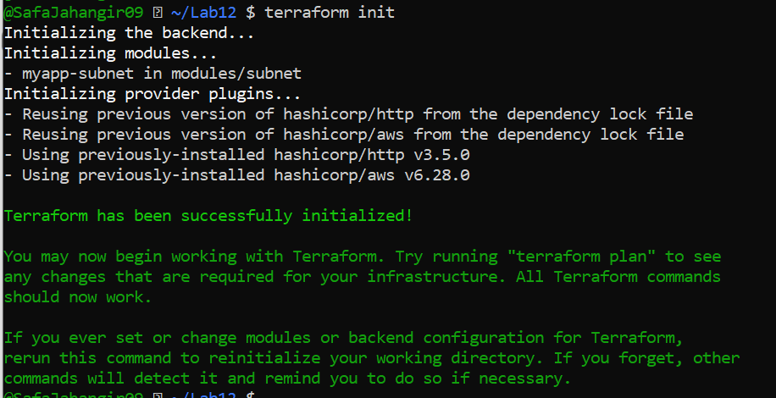

* task4_terraform_apply.png

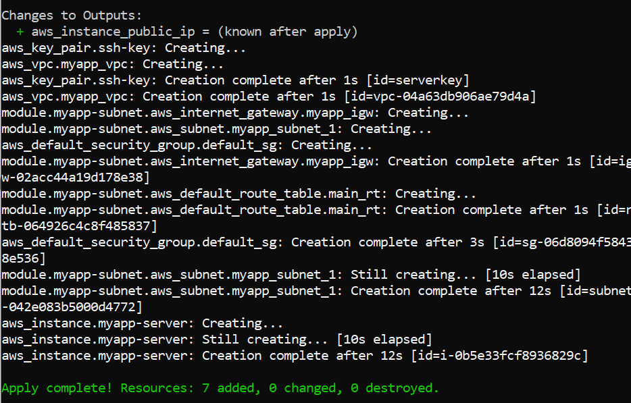

* task4_terraform_output.png

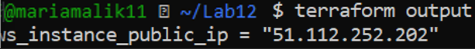

* task4_nginx_browser.png

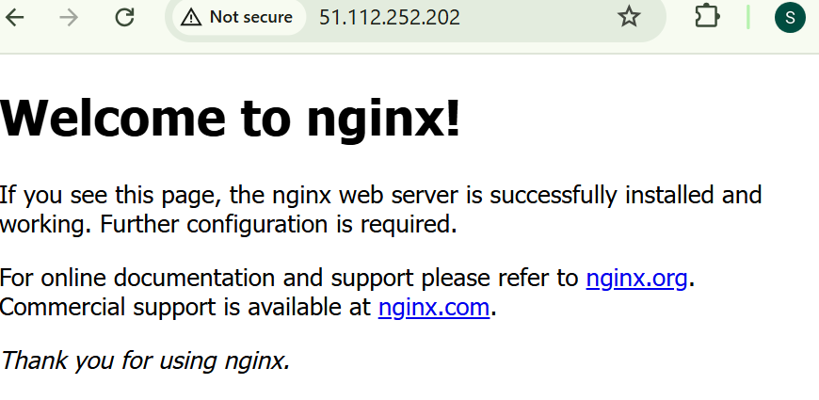

## Task 5 — Create webserver module

* task5_webserver_module_structure.png

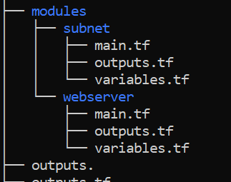

* task5_webserver_variables.png

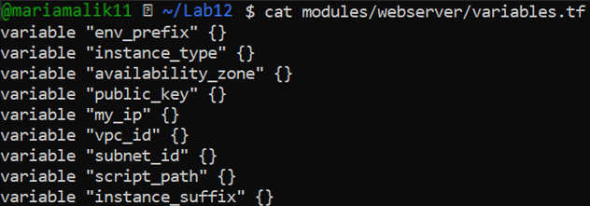

* task5_webserver_main.png

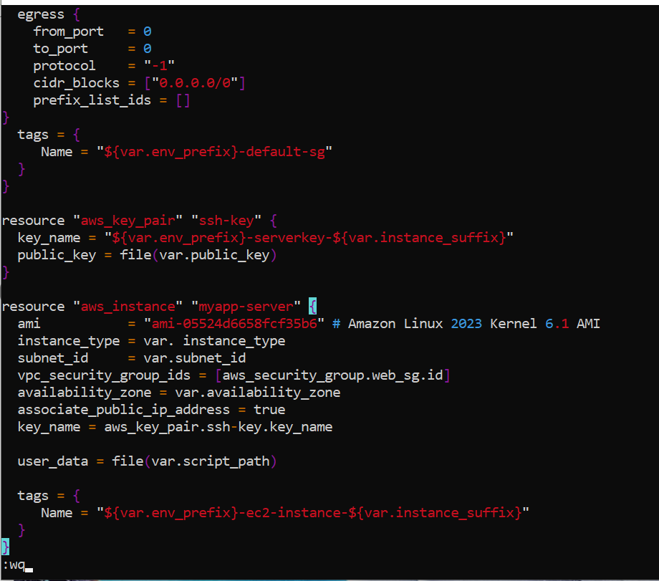

* task5_webserver_outputs.png

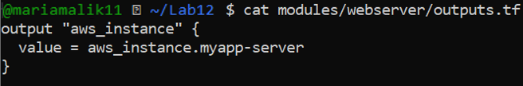

* task5_main_tf_webserver_module.png

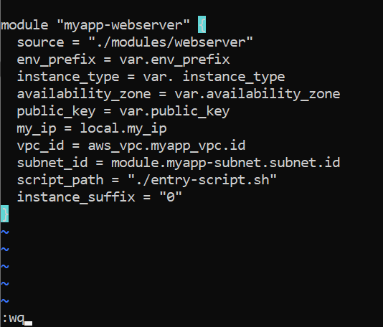

* task5_outputs_updated.png

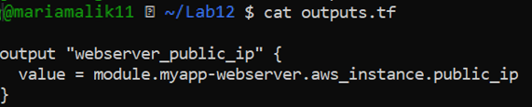

* task5_terraform_init.png

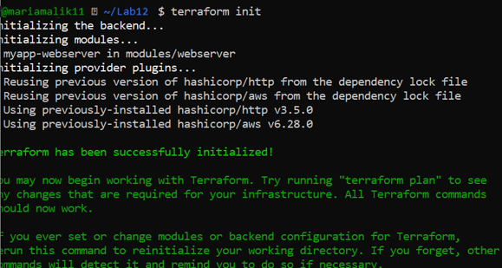

* task5_terraform_apply.png

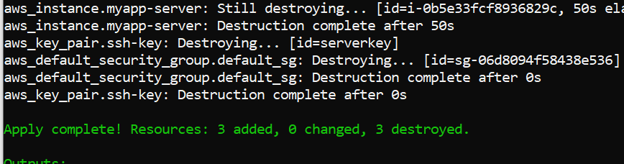

* task5_nginx_browser.png

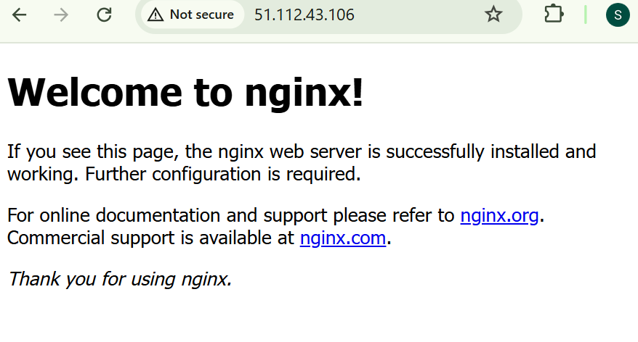

* task5_terraform_destroy.png

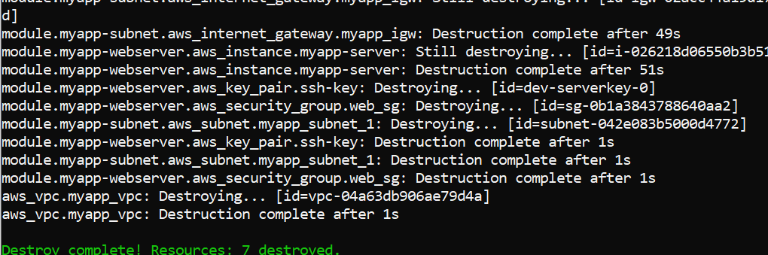

## Task 6 — Configure HTTPS with self-signed certificates

* task6_entry_script_https.png

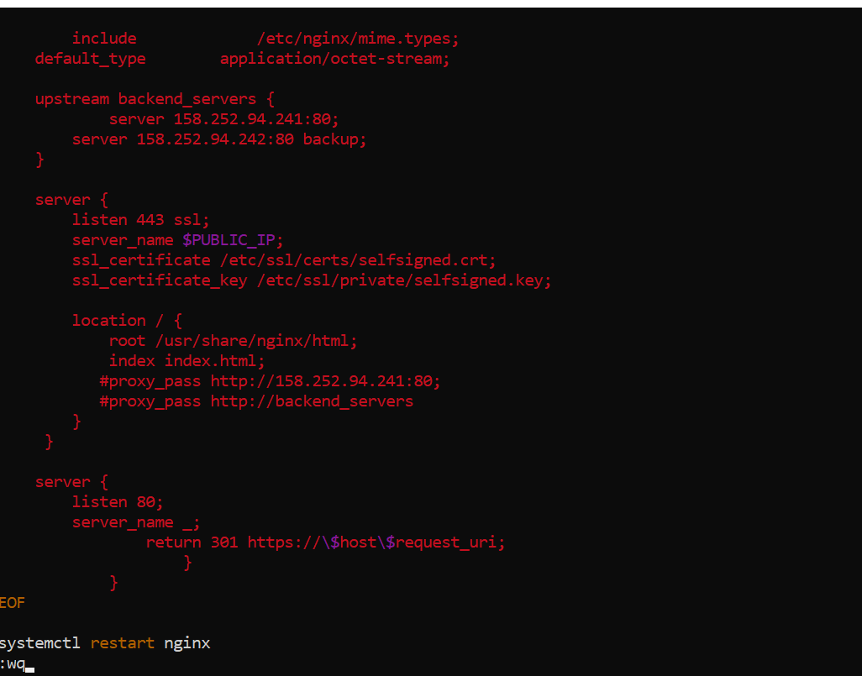

* task6_terraform_apply.png

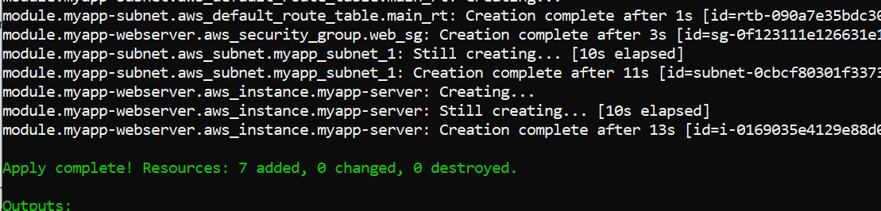

* task6_browser_security_warning.png

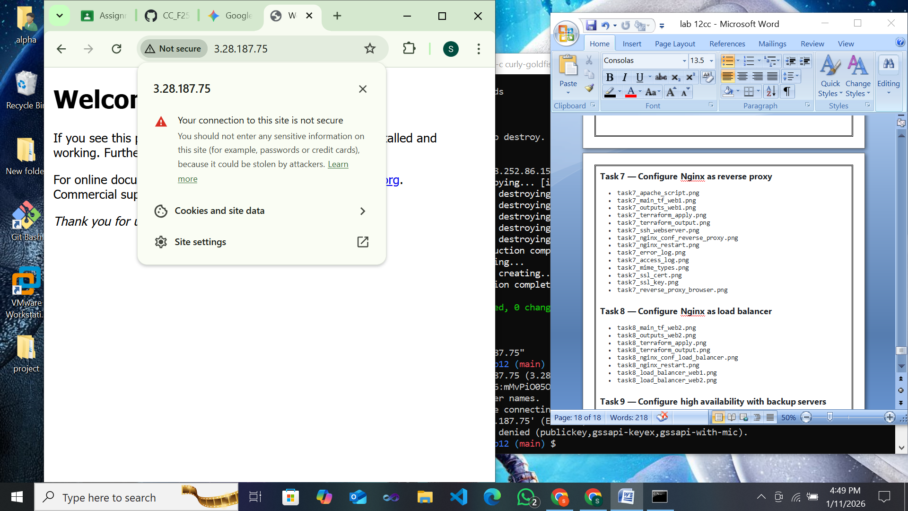

* task6_nginx_https_browser.png

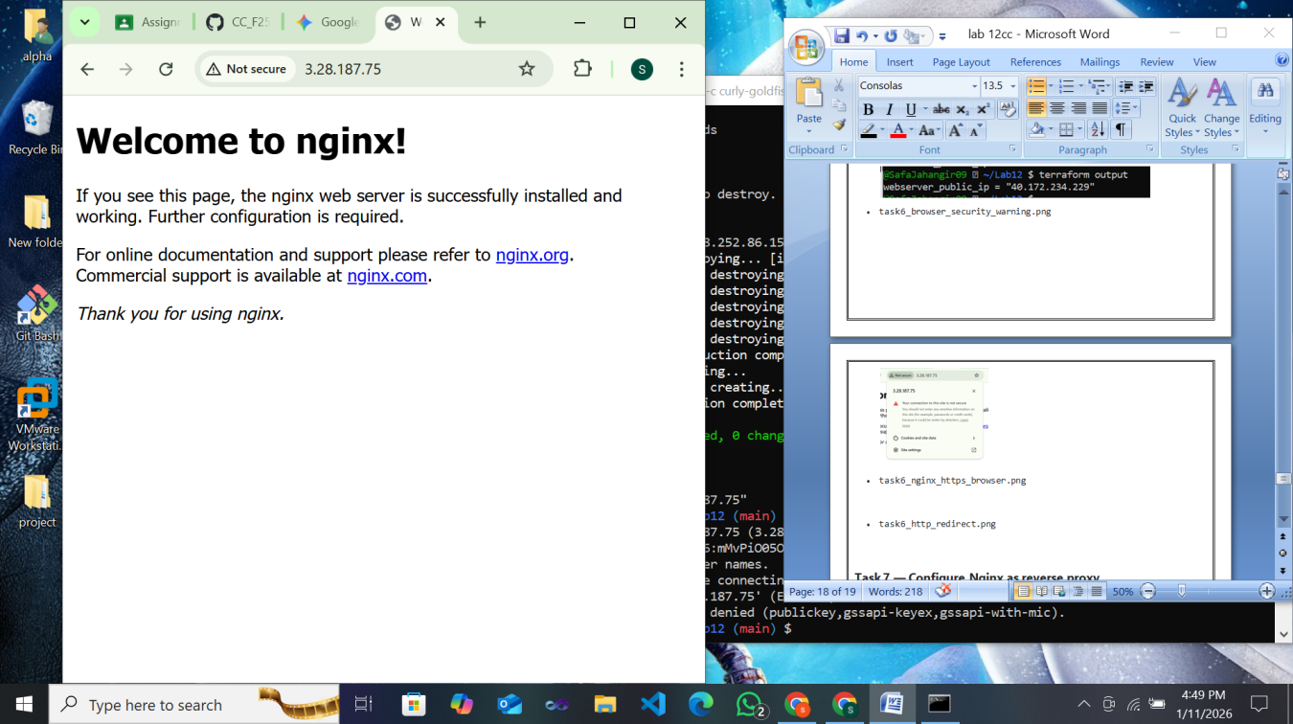

## Task 7 — Configure Nginx as reverse proxy

* task7_apache_script.png
* 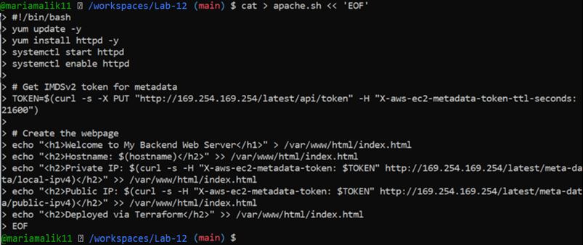
* task7_main_tf_web1.png

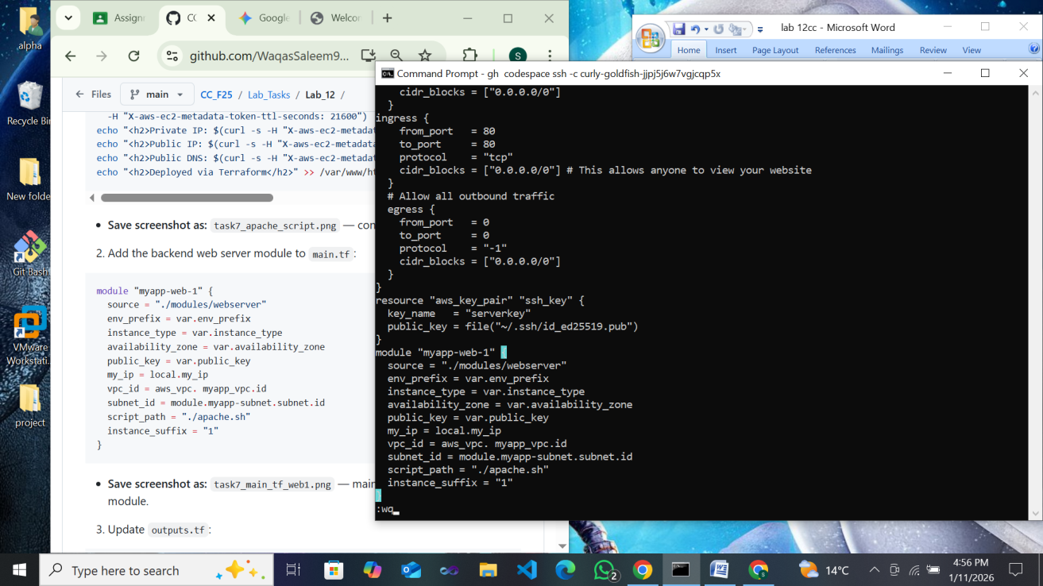

* task7_outputs_web1.png

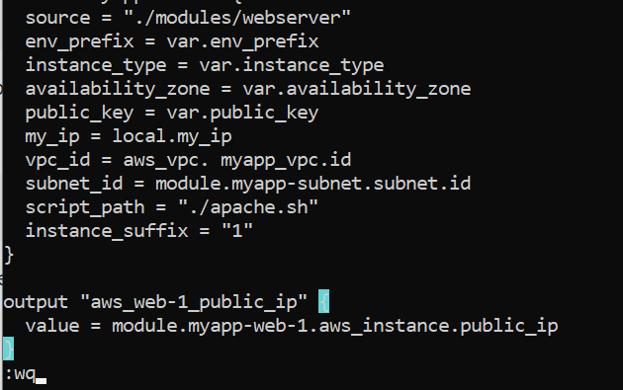

* task7_terraform_apply.png

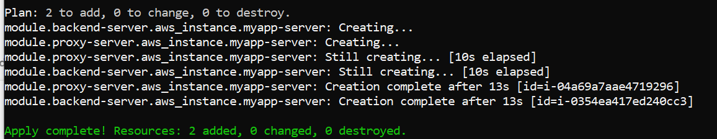

* task7_terraform_output.png

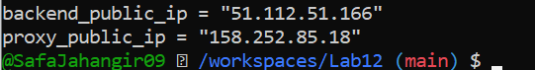

* task7_ssh_webserver.png

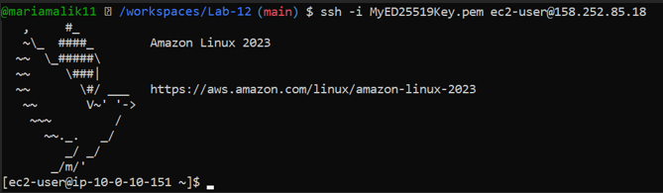

* task7_nginx_conf_reverse_proxy.png

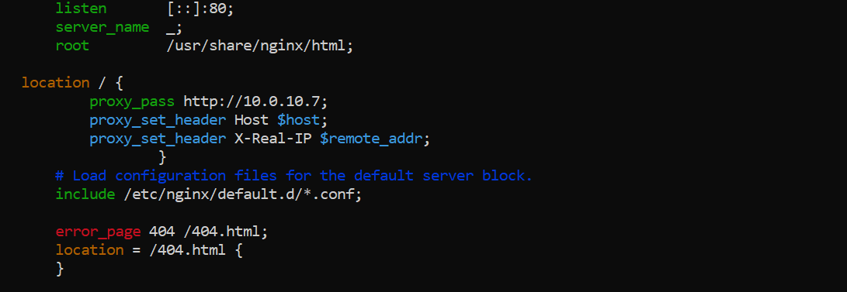

* task7_nginx_restart.png



* task7_error_log.png

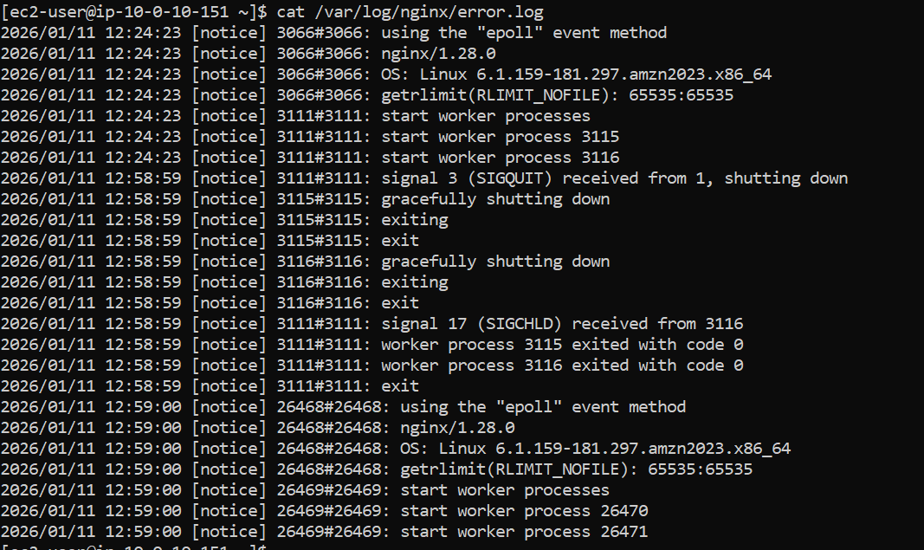

* task7_access_log.png



* task7_mime_types.png

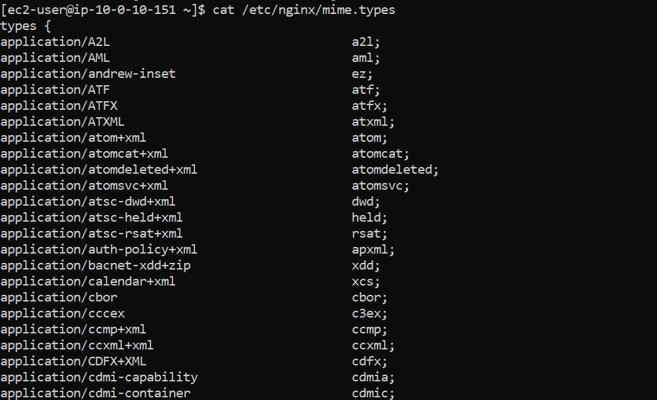

* task7_ssl_cert.png



* task7_ssl_key.png



* task7_reverse_proxy_browser.png

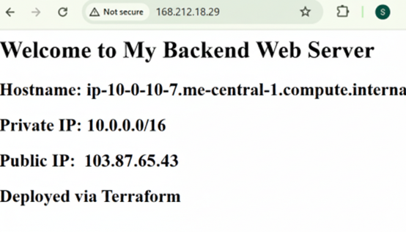

## Task 8 — Configure Nginx as load balancer

* task8_main_tf_web2.png

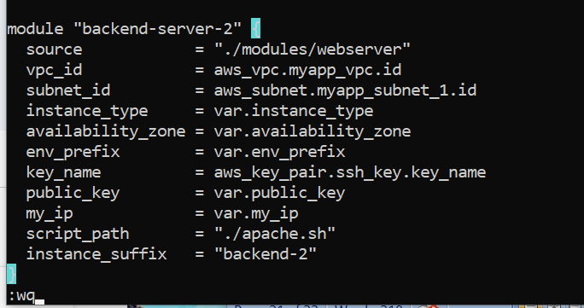

* task8_outputs_web2.png

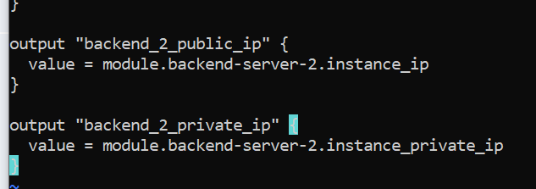

* task8_terraform_apply.png

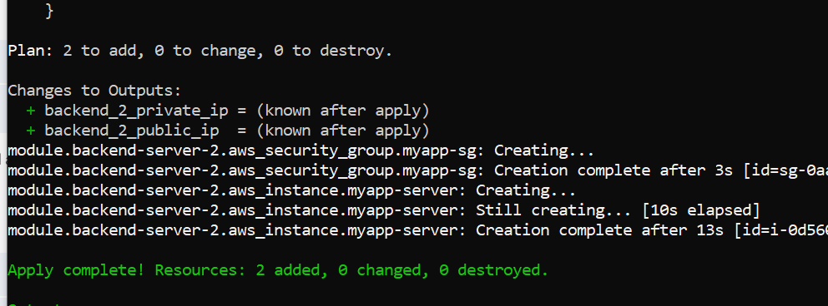

* task8_terraform_output.png

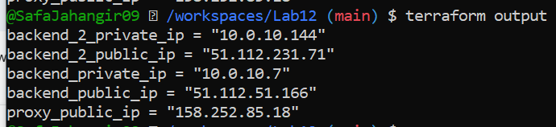

* task8_nginx_conf_load_balancer.png

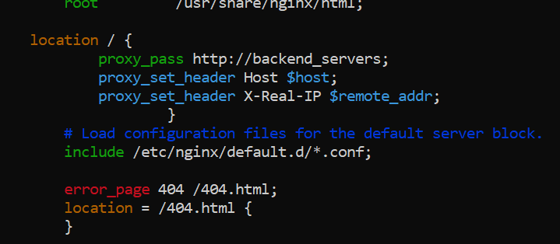

* task8_nginx_restart.png



## Task 9 — Configure high availability with backup servers

* task9_nginx_conf_ha_web1_primary.png

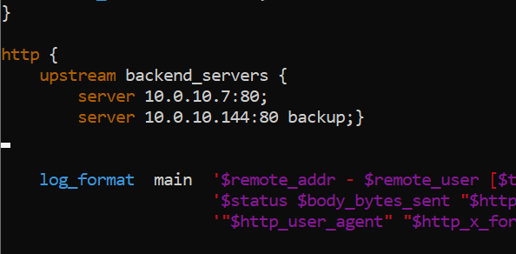

* task9_ha_web1_only.png

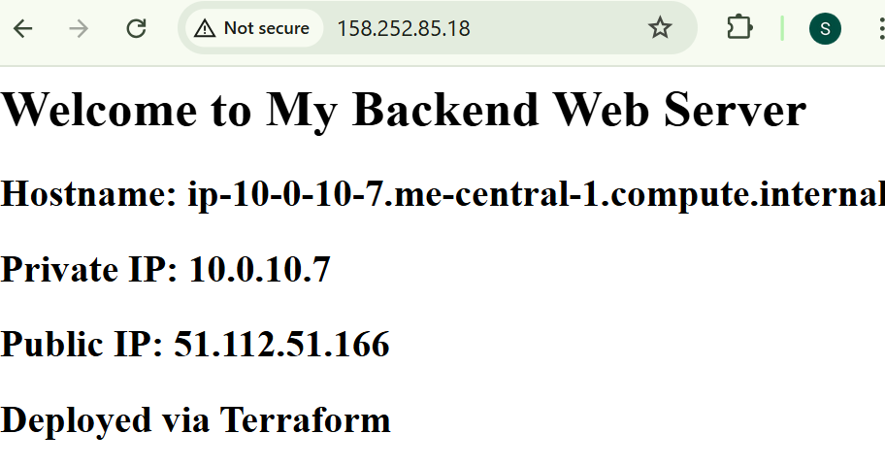

* task9_nginx_conf_ha_web2_primary.png

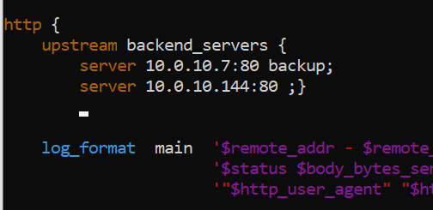

* task9_ha_web2_only.png

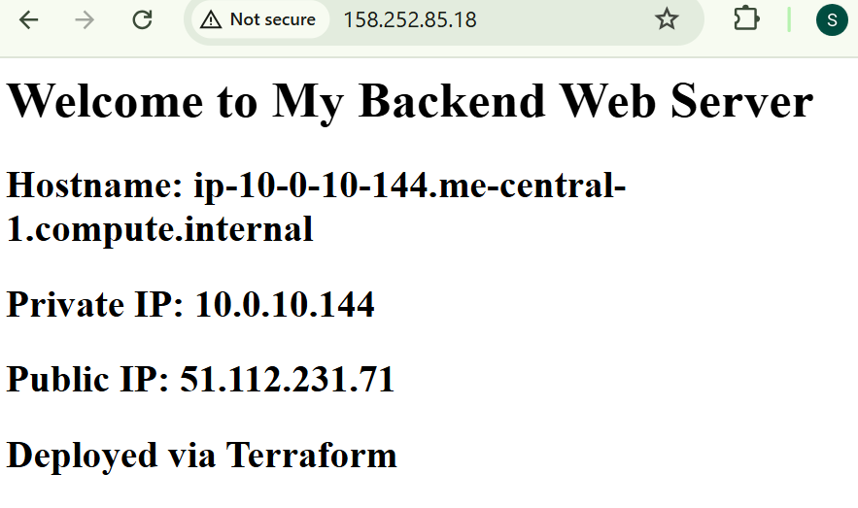

## Task 10 — Enable Nginx caching

* task10_nginx_conf_cache.png

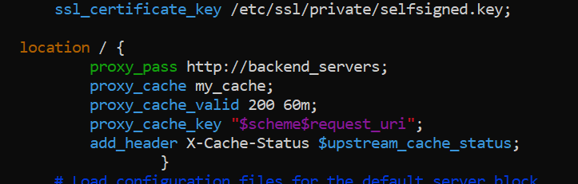

* task10_nginx_restart.png

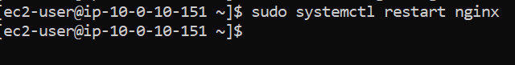

* task10_cache_miss.png

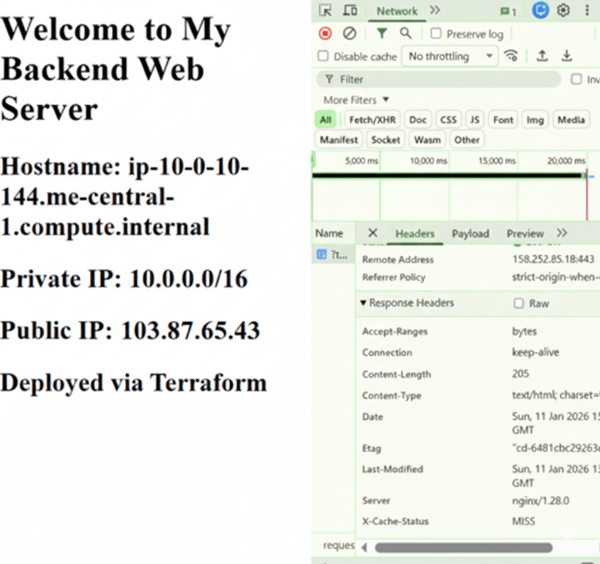

* task10_cache_directory.png

